

# Site Table of Contents

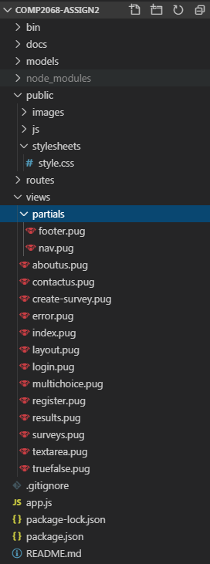

# App Details

Our polls and surveys app is able to allow a user to register and login to the site. Registering gives the user the ability to create true and false, multiple choice and text-based answer surveys for free and store them in our site’s database. The surveys can contain as many questions as a user wants/needs and for multiple choice, add as many choice options as needed. Our home page also features some resources for beginners to consider when creating their surveys in order to help them create a survey that gets them the information they are searching for from their target audience.

# Screenshot Selections

Unable to take final screenshots of the web app due to the MongoDB failing on the final day.

# Potential Future Functionality

Due to time constraints, features that could be added to the application in the future but do not currently exist are:

1. A site forums or mentor feature for users to discuss with other users and get advice on designing their surveys.
2. The ability for users to let an audience take their survey online through the spreading of a survey link similar to how Google Docs lets anyone who has a copy of the document link access that person’s document.
3. A page from which a user can view all surveys they have created and saved to the database (unable to get MongoDB working to finish this page. The unfinished page is located on the application under “Surveys” on the navigation bar and surveys.pug in the table of contents).
4. A more detailed document library to provide more starter support for a wider variety of topics regarding survey creation, conducting and how to process the data you’ve gathered post-survey through statistical math such as standard deviation and normalization curves.
5. The ability to create more survey types.
6. The ability to generate charts of the results from surveys taken in app.